**Practical No.01**

* **MongoDB Basics**

1. **Write a MongoDB query to create and drop database.**

**Query and Output:**

1. use school



1. show dbs



1. db.student.insert([{"Name":"abc","RollNo":101},{"Name":"abc","RollNo":102},{"Name":"abc","RollNo":103}])

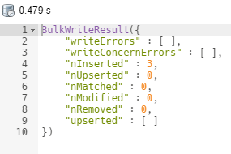

1. db.dropDatabase()

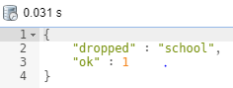

1. **Write a MongoDB query to create, display and drop collection.**

**Query and Output:**

1. db.createCollection("student")

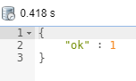

1. show collections

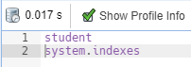

1. db.student.drop()

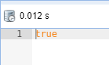

1. **Write a MongoDB query to insert, query, update and delete a document.**

**Query and Output:**

1. db.student.insert([{"Name":"abc","RollNo":101},{"Name":"abc","RollNo":102},{"Name":"abc","RollNo":103}])

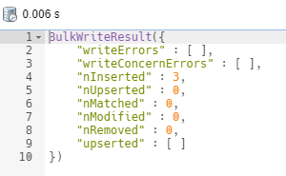

1. db.student.find()

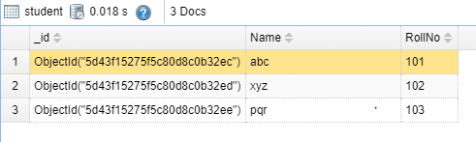

1. db.student.update({"Name":"pqr"},{$set:{"Name":"sk"}})

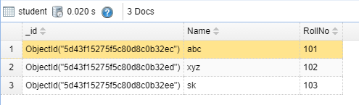

1. db.student.remove({"Name":"sk"})

